**Challenges in Developing “EduBites”**

**1. Database and Storage Constraints**

One of the core challenges for **EduBites** is the lack of access to a robust database and cloud storage solutions. Platforms like AWS provide scalable databases and storage options, but they come with significant costs, especially for a large-scale project like ours, where we need to store and manage thousands of videos, user data, and AI-generated recommendations. Without a cloud-based database (like AWS, Google Cloud, or Azure), we would struggle to:

1. Store and retrieve video content efficiently.
2. Handle large amounts of user data for personalized recommendations.
3. Ensure the data is secure and easily accessible across devices.

This lack of access to a proper cloud database would severely limit our ability to scale and manage the content.

**2. Lack of GPU and Computing Resources**

A major technical challenge for EduBites is the lack of GPU resources. Many of the AI models we plan to implement, such as those for video processing (e.g., transcribing, segmenting, and generating recommendations), require GPU acceleration for faster and more efficient processing. Without GPUs, our system will face:

1. Extremely slow video processing, which is especially important when converting long educational videos into short-form content.
2. Increased processing times for generating personalized recommendations.
3. Inability to scale the system as user engagement grows, leading to slow and inefficient responses.

Running such operations on CPUs alone will result in bottlenecks and would significantly reduce the performance of our platform.

**3. Challenges in Video Streaming and Scrolling Mechanism**

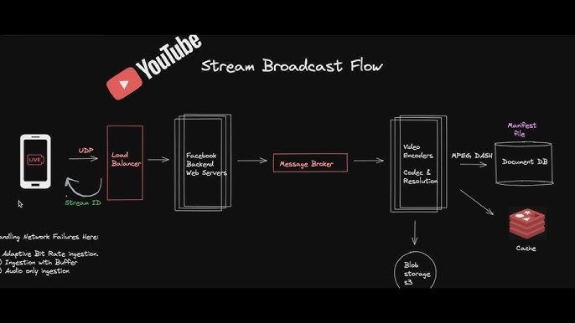

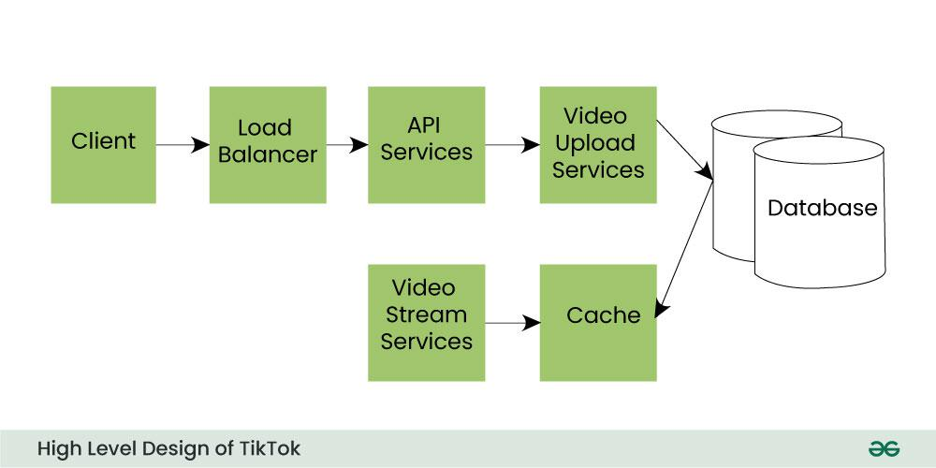

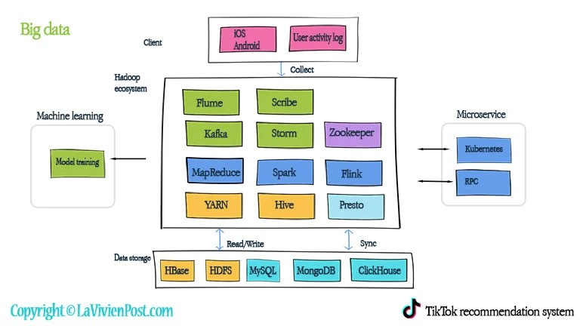

One of the standout features of platforms like TikTok or YouTube Shorts is the smooth, seamless video scrolling experience, where users can quickly move from one video to the next. Achieving this requires efficient streaming and caching mechanisms, supported by high-performance cloud infrastructure. Since we lack access to these cloud resources, several issues arise:

1. Our platform will likely struggle with high latency when streaming videos, leading to poor user experience.
2. Server overload could occur when multiple users are interacting with the platform simultaneously, especially as video files are large and require considerable bandwidth.
3. Without scalable cloud solutions, our system could potentially crash when handling real-time video streaming for multiple users.

This issue would directly affect the core user experience and the viability of the platform.

**4. Complexities in Video Conversion and Segmentation**

One of our key features is converting long educational videos into short, digestible clips. However, this presents a significant technical challenge:

1. The process of splitting long videos into meaningful short segments requires not only a powerful GPU but also advanced AI models that can understand and segment the content based on context.
2. Video segmentation and processing are resource-intensive tasks, requiring both computational power and efficient algorithms. Doing this on regular hardware without cloud resources or GPUs would lead to extremely slow processing times and would drastically limit our ability to deliver content quickly.

Without sufficient resources, converting and managing video content at scale will be an uphill battle.

**5. Limited Expertise in Advanced Streaming and AI Technologies**

As a team, we lack expertise in some of the advanced technologies required to build a sophisticated platform like EduBites. Key areas where we are lacking include:

- Streaming technologies: We need expertise in developing a robust video streaming solution similar to TikTok or YouTube Shorts, which involves complex server architecture and video handling mechanisms.

- AI for video processing: Building intelligent agents that can automatically segment videos based on educational content requires advanced knowledge of machine learning and natural language processing (NLP), which we may not fully possess.

- Real-time scalability: Ensuring the platform can scale with increased traffic and user interactions requires deep understanding of cloud architecture, load balancing, and distributed systems, areas in which we might have limited experience.

This lack of expertise may prevent us from achieving the high level of functionality we are aiming for.

**6. Infrastructure Costs and Scalability Issues**

To make EduBites a fully operational platform, we need access to scalable cloud infrastructure that can support real-time streaming, storage, and AI-based video processing. The costs associated with such infrastructure are significant:

1. Cloud storage costs for hosting thousands of videos, especially as the platform scales, will grow quickly.
2. GPU costs for AI processing and video conversion are substantial, and without a cloud solution, it's infeasible to achieve the performance we need.
3. Ensuring 24/7 uptime with low latency video streaming requires expensive cloud services, which are currently beyond our budget.

Without the ability to afford and maintain such infrastructure, our platform will struggle to deliver the experience we envision.

**Conclusion**

As much as EduBites is an exciting and innovative project, the above-mentioned challenges highlight significant barriers to its development at our current level of expertise and resources. We are constrained by the lack of database and storage solutions, GPU power, and streaming infrastructure, all of which are crucial for a platform that requires seamless video delivery and AI-driven personalization. While these problems don't mean the project is impossible, they present serious roadblocks that we must consider as a team before moving forward.